

**Department of Software Engineering**

**Faculty of Computer Science & Information Technology**

**The Superior University, Lahore**

**Name:** MUHAMMAD HAMZA ALI

**Roll No:** SU92-BSAIM-S24-032

**Section:** 3A

**Subject:** ARTIFICIAL INTELLIGENCE(LAB)

**Task No:** Lab-Task 5(Task-2)

**Task-5**

**Inorder, Preorder, Postorder**

**1. Introduction:**

The objective of this task is to research and implement three types of Depth-First Search (DFS) tree traversal techniques: Inorder, Preorder, and Postorder. These traversal methods are used to systematically visit all nodes in a binary tree.

**2. Features:**

* Define a Node class to represent tree nodes.
* Implements recursive methods for Inorder, Preorder, and Postorder traversals.
* Uses a binary tree structure with a root node and child nodes.
* Outputs the traversal order directly to the console.

**3. Implementation Details:**

The implementation defines a Node class for constructing a binary tree and a Tree class containing methods for the three traversal techniques.

**4. User Interaction:**

* The recursive approach is simple and effective for tree traversal.
* Using an iterative approach with a stack may improve efficiency for large trees.
* Additional features such as tree depth calculation and level order traversal could enhance functionality.
* Improving user interaction by accepting tree input dynamically could make the program more flexible.

**5. Output:**

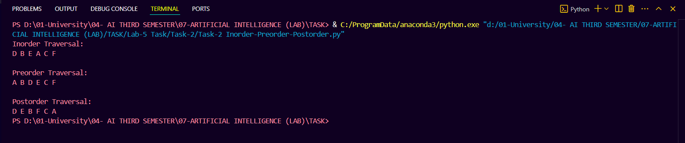

**6. Conclusion:**

This task successfully demonstrates three fundamental tree traversal techniques. Future enhancements could include iterative methods, additional traversal techniques, and interactive tree input handling.